Seventh Sunday after Pentecost
Sunday, July 28, 2019
Welcome! Please sign the red attendance pad as it passes down your pew. If you are a first-time visitor, please complete a yellow card and drop in the offering plate. For prayer requests, simply complete a blue card and place it in the offering plate for inclusion in today’s Pastoral Prayer.

Order of Worship

Welcome & Announcements Celene Terry

*Passing of the Peace ”God’s Wonderful People” Celene Terry

The Chiming of the Hour and Procession of the Acolyte

*Call to Worship “Sweet, Sweet Spirit” UMH 334

*Scripture Reading Colossians 2:6-15 Ralaine Manning

*Hymn “Stand Up, Stand Up for Jesus” UMH 514

*Offertory Prayer Celene Terry

Offertory

*Doxology UMH 95

Pastoral Prayer/The Lord’s Prayer Rev. Dan Gurley

Pastor’s Pals Rev. Gurley

*Apostles’ Creed Celene Terry UMH 881

*Gloria Patri UMH 70

*Hymn “When We All Get to Heaven” UMH 701

Anthem

*Scripture Reading & Prayer Rev. Gurley

Message Rev. Gurley

*Hymn of Invitation “Softly and Tenderly Jesus Is Calling” UMH 348 vs.1-2

*Benediction Rev. Gurley

*Benediction Song “Revive Us Again” *See Screens

*Postlude

*Stand if able: UMH=United Methodist Hymnal, TFWS=The Faith We Sing.

Nurture Therefore encourage one another and build up one another, just as you also are doing. --1 Thessalonians 5:11

New Prayers: Continued Prayers:

Our Church  Claire Stout  Ted Stout  Linda Harris  Tonya Bonsal  Kayla Bonsal  Savannah Chapman  Richard Stahl | Tyson Adams  Wyatt Alexander,  Mary Bonsal,  Greta Boultinghouse, Ray Bourre  Jack Brandy,  Sammy Coleman, Bill Cross,  Barbara Hamilton,  Mary Henderson,  Skyler Hicks, Tommy Jobe,  Becky Kay, Becky Keele,  Levon Kristmer,  Linda Kuykendall  Virginia Lane, Knox Lowe,  Willie Lundy, Paulette Martin,  Debbie Wrinkle McAllister  Suzie McCarthy,  Rev. Ella McDonald,  John McMillian, Janson Morgan, Matthew Mutz, Sherry Nash, Whitney Nunn, John Otto,  Lyndon & Beverly Patrick,  Clara Ries, Tabitha Roberts,  Jordan Toon, Dee & Don Trull, Alice West, John White, & Meredith Williams. | Angels In The Wings:  Adda Beamgard Gladys Caulking  J.C. Crow  Patrick Fremming Mary Friedel Loretta Hamilton Jessie Kelley  Benita King  Mary Jo Lemons Pam Long Shirley Menasco  Betty Pollock  Charlotte Reppen  Cynthia Van Pelt-Sperry Pat Underriner Peggy Whisenant

Financial Report: January-June 2019 Income: $327,357.58
Expense: ($259,725.31)

Don’t Forget….
You can give/tithe online through FUMCMabank.com.

Visit our Serve tab and click on the
Serve Through Giving page.

Or visit: https://www.fumcmabank.com/serve/serve-through-giving/
Church Staff:
Senior Pastor: Rev. Dan Gurley
dan@fumcmabank.com

Associate Pastor: Allison Partridge
The Foundry House

Custodian: Kim Grimes

Director of Communications: Kelly Sasenbery
kelly@fumcmabank.com

Director of Music Ministries: Aaron Strum
aaron@fumcmabank.com

Financial Administrator: Rhonda Jones
rhonda@fumcmabank.com

Nursery Attendants: Yolanda & Carolyn Jimenez

Office Administrator & Pianist: Lance Douglas Gutierrez
lance@fumcmabank.com

Organist: Janice Sutton

Student Ministries Director: Olivia Pannell
olivia@fumcmabank.com

Church Hours:
Monday - Thursday: 9:00 a.m. – 3:00 p.m.
Friday & Saturday: Closed

Helping Hands Desk:
Tuesday – Thursday
9:00 - 11:00 a.m. – 1:00 - 3:00 p.m.

Sunday Schedule:
Sunday School at 9:00 a.m. for all ages.
Worship at 10:00 a.m.

*Holy Communion is shared on the 1st Sunday of each month.
On the third Sunday, communion is available in the Wesley Chapel immediately after service.

Ⓒ2019 FUMC Mabank, All rights reserved. CCLI #183424

Would you like to know more about Jesus Christ, how to become a Christian or would like more information about church membership? Perhaps you just need
someone to pray with or talk to you. Please let us know!

July 28, 2019
Seventh Sunday after Pentecost
10:00 a.m. Worship Service.
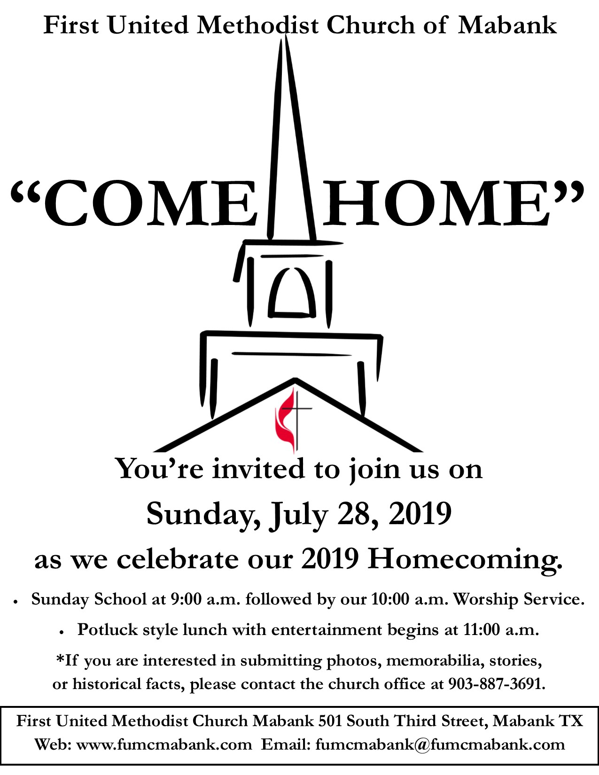

First United Methodist Church
501 South Third Street
Mabank, TX 75147

Phone: 903-887-3691 Fax: 903-887-0670
www.fumcmabank.com

