19th Sunday after Pentecost
Sunday, October 20, 2019
Welcome! Please sign the red attendance pad as it passes down your pew. If you are a first-time visitor, please complete a yellow card and drop in the offering plate. For prayer requests, simply complete a blue card and place it in the offering plate for inclusion in today’s Pastoral Prayer.

Order of Worship

Welcome & Announcements Celene Terry

*Passing of the Peace ”God’s Wonderful People” Celene Terry

The Chiming of the Hour and Procession of the Acolyte

*Call to Worship “God Is Here” UMH 660 vs. 1

*Scripture Reading 2 Timothy 3:14 - 4:5 Celene Terry

*Hymn “Come, Christians, Join to Sing” UMH 158

*Offertory Prayer Celene Terry

Offertory

*Doxology UMH 95

Pastoral Prayer/The Lord’s Prayer Rev. Dan Gurley

Pastor’s Pals Rev. Gurley

Apostles’ Creed UMH 881 Celene Terry

Gloria Patri UMH 70

*Hymn ”Love Divine, All Loves Excelling” UMH 384

Anthem Jubilation 5

*Scripture Reading & Prayer Luke 18:1-8 Rev. Gurley

Message Rev. Gurley

*Hymn of Invitation “Just as I am, Without One Plea” UMH 357 vs. 1-2

*Benediction Rev. Gurley

*Benediction Song “Sent Forth by God’s Blessing” UMH 664 vs. 1

*Postlude

*Stand if able: UMH=United Methodist Hymnal, TFWS=The Faith We Sing.
Nurture Therefore encourage one another and build up one another, just as you also are doing. --1 Thessalonians 5:11

New Prayers: Continued Prayers:

Our Church  Oliver C. Hogue  Tyson Johnson  Kelli Janway  Michelle Steuber  Russ Bruno  Rose Giordand  The Denson Family  The Wade Family Madison Jordon David Claude Jacqueline Lewis Cassandra Hunter | Wyatt Alexander,  Kayla and Mary Bonsal,  Greta Boultinghouse,  Ray Bourre,  Jack Brandy,  Peggy Broyles,  Kelly Chancellor,  Savannah and David Chapman,  Sammy Coleman,  Bill Cross, Chris Ensley,  Barbara Hamilton,  Mary Henderson,  Matt Herron, Jean Hyde  Becky Keele, Jean Kines,  Levon Kristmer,  Virginia Lane, Bill Lane,  Willie Lundy, Paulette Martin,  Debbie McAllister  Rev. Ella McDonald,  John McMillian, Terry Morales, Rhonda Morgan, Sherry Nash,  Whitney Nunn, John Otto,  Lyndon & Beverly Patrick,  Lee Perkins, Matthew Rabone, Clara Ries, Scott Smith,  Jim Starrett, Jordan Toon, Dee & Don Trull, & John White. | Angel’s In The Wings:  Adda Beamgard Gladys Caulking  Mary Friedel Loretta Hamilton  Tommy Jobe  Jessie Kelley  Benita King  Linda Kuykendall  Mary Jo Lemons Pam Long  Knox Lowe Shirley Menasco  Betty Pollock  Charlotte Reppen  Cynthia Van Pelt-Sperry Pat Underriner Peggy Whisenant

Financial Report: January-September 2019 Income: $453,784.30
Expense: ($400,924.80)

Don’t Forget….
You can give/tithe online through FUMCMabank.com.

Visit our Serve tab and click on the
Serve Through Giving page.

Or visit: https://www.fumcmabank.com/serve/serve-through-giving/
Church Staff:
Senior Pastor: Rev. Dan Gurley
dan@fumcmabank.com

Foundry House Ministries: Allison Partridge

Custodian: Kim Grimes

Director of Communications: Kelly Sasenbery
kelly@fumcmabank.com

Director of Music Ministries: Aaron Strum
aaron@fumcmabank.com

Financial Administrator: Rhonda Jones
rhonda@fumcmabank.com

Nursery Attendants: Yolanda & Carolyn Jimenez

Office Administrator & Pianist: Lance Douglas Gutierrez
lance@fumcmabank.com

Organist: Janice Sutton

Student Ministries Director: Olivia Pannell
olivia@fumcmabank.com

Church Hours:
Monday - Thursday: 9:00 a.m. – 3:00 p.m.
Friday & Saturday: Closed

Helping Hands Desk:
Tuesday – Thursday
9:00 - 11:00 a.m. – 1:00 - 3:00 p.m.

Sunday Schedule:
Sunday School at 9:00 a.m. for all ages.
Worship at 10:00 a.m.

*Holy Communion is shared on the 1st Sunday of each month.
On the third Sunday, communion is available in the Wesley Chapel immediately after service.

Ⓒ2019 FUMC Mabank, All rights reserved. CCLI #183424

Would you like to know more about Jesus Christ, how to become a Christian or would like more information about church membership? Perhaps you just need
someone to pray with or talk to you. Please let us know!

October 20, 2019
Nineteenth Sunday after Pentecost

10:00 a.m. Worship Service
Rev. Dan Gurley

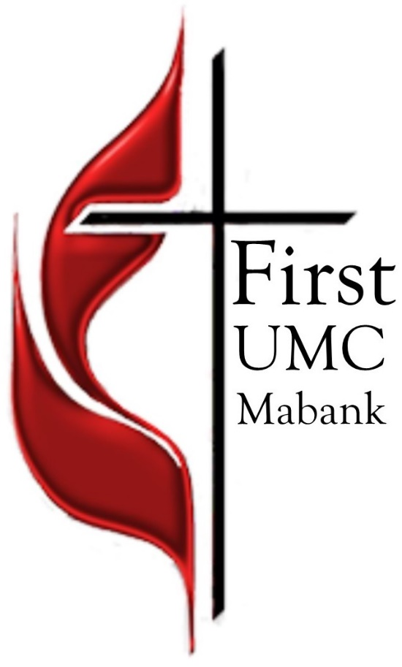

First United Methodist Church
501 South Third Street
Mabank, TX 75147

Phone: 903-887-3691 Fax: 903-887-0670
www.fumcmabank.com

