Second Sunday of Advent
Sunday, December 8, 2019

Welcome! Please sign the red attendance pad as it passes down your pew.
If you are a first-time visitor, please complete a yellow card and drop in the offering plate. For prayer requests, simply complete a blue card and place it in the offering plate for
inclusion in today’s Pastoral Prayer.

Order of Worship

Welcome & Announcements Linda Jackson

Called Meeting

*Passing of the Peace ”God’s Wonderful People” Linda Jackson

The Chiming of the Hour and Procession of the Acolyte

*Call to Worship “Emmanuel, Emmanuel” UMH 204

Lighting of the Advent Candle Richard and Linda Jackson

*Hymn “O Little Town of Bethlehem” UMH 230

*Offertory Prayer Linda Jackson

Offertory

*Doxology UMH 95

Pastoral Prayer/The Lord’s Prayer Rev. Dan Gurley

Children’s Time Chrismon Reading

*Hymn ”Once in Royal David’s City” UMH 250

Special Music

*Scripture Reading & Prayer Matthew 3:1-12 Rev. Gurley

Message Rev. Gurley

*Hymn of Invitation “Hail to the Lord’s Anointed” UMH 203 vs. 1-2

*Benediction Rev. Gurley

*Postlude

*Stand if able: UMH=United Methodist Hymnal, TFWS=The Faith We Sing.

Nurture Therefore encourage one another and build up one another, just as you also are doing. --1 Thessalonians 5:11

New Prayers: Continued Prayers:

Our Church  Annie Garnica  Cathy Hughes  Linda Kay Brown  Jo Gregg  Ruby Snow  Cathy Hughes  Cheryl Nekuza  Mary Stockton  Sympathy:  Family and friends of Mary Bonsal.  Morris Mewbourn Family.  Family and friends of Willie Richardson. | Diane Ackles,  Wyatt Alexander, Mary Allen,  Joaquin Bejarand,  Greta Boultinghouse,  Ray Bourre, Tony Boyd,  Jack Brandy, Kelly Chancellor,  Sammy Coleman,  Bill Cross, Chris Ensley,  Barbara Hamilton, Matt Herron,  Curtis Himes, Jean Hyde,  Kelli Janway, Jaci Johnson  James Jones, Madison Jordon, Becky Keele, Levon Kristmer, Virginia Lane, Paulette Martin,  Rev. Ella McDonald,  John McMillian,  Bill Morgan, Rhonda Morgan,  Jean Morrow, Sherry Nash,  John Otto, Lyndon Patrick,  Lee Perkins, Joe Pickens,  Matthew Rabone,  Clara Ries, Donnie Roberts,  Mary Smith, Kye Smith, Scott Smith, Jim Starrett, Dee & Don Trull,  John White, Stuart Weatherford,  and T.J. Wiersgalla. | Angel’s In The Wings:  Adda Beamgard  Gladys Caulking  Mary Friedel  Tommy Jobe  Jessie Kelley  Benita King  Linda Kuykendall  Mary Jo Lemons Pam Long  Knox Lowe Shirley Menasco  Betty Pollock  Charlotte Reppen  Cynthia Van Pelt-Sperry Pat Underriner Peggy Whisenant

Financial Report: January-November 2019 Income: $533,837.65
Expense: ($519,105.12)

Don’t Forget….
You can give/tithe online through FUMCMabank.com.

Visit our Serve tab and click on the
Serve Through Giving page.

Or visit: https://www.fumcmabank.com/serve/serve-through-giving/
Church Staff:
Senior Pastor: Rev. Dan Gurley
dan@fumcmabank.com

Foundry House Ministries: Rev. Allison Partridge

Custodian: Kim Grimes

Director of Communications: Kelly Sasenbery
kelly@fumcmabank.com

Director of Music Ministries: Aaron Strum
aaron@fumcmabank.com

Financial Administrator: Rhonda Jones
rhonda@fumcmabank.com

Nursery Attendants: Yolanda & Carolyn Jimenez

Office Administrator & Pianist: Lance Douglas Gutierrez
lance@fumcmabank.com

Organist: Janice Sutton

Director of Children’s Ministries: Linda Jackson

Director of Youth Ministries: Olivia Pannell
olivia@fumcmabank.com

Church Hours:
Monday - Thursday: 9:00 a.m. – 3:00 p.m.
Friday & Saturday: Closed

Helping Hands Desk:
Tuesday – Thursday
9:00 - 11:00 a.m. – 1:00 - 3:00 p.m.

Sunday Schedule:
Sunday School at 9:00 a.m. for all ages.
Worship at 10:00 a.m.

*Holy Communion is shared on the 1st Sunday of each month unless noted otherwise. On the third Sunday, communion is available in the Wesley Chapel immediately after service.

Ⓒ2019 FUMC Mabank, All rights reserved. CCLI #183424

Would you like to know more about Jesus Christ, how to become a Christian or would like more information about church membership? Perhaps you just need
someone to pray with or talk to you. Please let us know!

December 8, 2019
2nd Sunday of Advent

10:00 a.m. Worship Service.
Rev. Dan Gurley

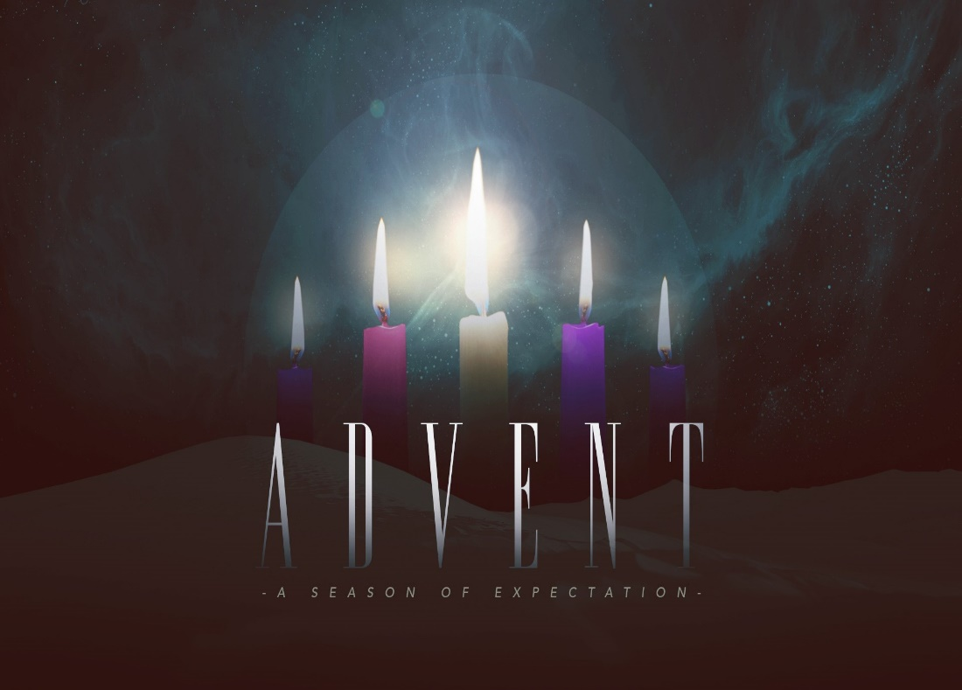

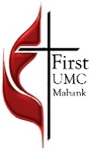
First United Methodist Church
501 South Third Street
Mabank, TX 75147

Phone: 903-887-3691 Fax: 903-887-0670
www.fumcmabank.com

