Transfiguration Sunday
Sunday, February 23, 2020

Welcome! Please sign the red attendance pad as it passes down your pew.
If you are a first-time visitor, please complete a yellow card and drop in the offering plate. For prayer requests, simply complete a blue card and place it in the offering plate for
inclusion in today’s Pastoral Prayer.

Order of Worship

Welcome & Announcements Mary Brown

*Passing of the Peace ”God’s Wonderful People” Mary Brown

The Chiming of the Hour and Procession of the Acolyte

*Call to Worship “All Hail King Jesus” TFWS 2069

*Scripture Reading 2 Peter 1:16-21 Mary Brown

*Hymn “Holy, Holy, Holy! Lord God Almighty” UMH 64

*Offertory Prayer Mary Brown

Offertory

*Doxology UMH 95

Pastoral Prayer/The Lord’s Prayer Rev. Dan Gurley

Pastor’s Pals Rev. Gurley

*Apostles’ Creed Mary Brown

*Gloria Patri

*Hymn ”Lord, I Lift Your Name on High” TFWS 2088

Anthem ”I Stand Amazed in the Presence” Chancel Choir

*Scripture Reading & Prayer Matthew 17:1-8 Rev. Gurley

Message Rev. Gurley

*Hymn of Invitation “Turn Your Eyes upon Jesus“ UMH 349

*Benediction Rev. Gurley

*Postlude

*Stand if able: UMH=United Methodist Hymnal, TFWS=The Faith We Sing.

Nurture Therefore encourage one another and build up one another, just as you also are doing. --1 Thessalonians 5:11

New Prayers: Continued Prayers:

Our Church  Nancy Rommel  Tom Wheeler  Rob Ravens  Peggy Broyles  Judson Charlton  Cathy Martin  Megan Marriott  Macy Raburn  Mike Juhl  James Adams  Jaxson  Melinda Van Horn  Ronnie Gartrell  Walter Reaves  Ansley Jenkins  Harley Feltman  Sympathy:  Family of Bill Lane. | Diane Ackles,  Wyatt Alexander,  Alice Barker,  Paula Beamis,  Joaquin Bejarano, Chris Bonsal,  Greta Boultinghouse, Ray Bourre,  Joe Boyd, Jack Brandy,  Rhonda Brooks, Kelly Chancellor, Sue Cohn, Sammy Coleman,  Bill Cross, Scott Daniels, Pat Davis,  William Earley, Terry Evans,  Chris Ensley, Leela Garneca,  Matt Herron, Curtis Himes,  Trey Holthy, Wendy Horton,  Cathy Hughes, Jean Hyde,  Kelli Janway, Madison Jordon,  Becky Keele, Levon Kristmer,  Bill Lane, Virginia Lane,  Paulette Martin, Rev. Ella McDonald,  John McMillian, Rhonda Morgan  Jean Morrow, Sherry Nash,  Mitch Orr, John Otto,  Clara Ries, Donnie Roberts,  Kye Smith, Mary Smith, Scott Smith,  Patsy Speer, Jim Starrett,  Ethan Toler, Dee & Don Trull,  and T.J. Wiersgalla. | Angels In The Wings:  Adda Beamgard  Gladys Caulking  Mary Friedel  Tommy Jobe  Jessie Kelley  Benita King  Linda Kuykendall  Mary Jo Lemons Pam Long  Knox Lowe Shirley Menasco  Betty Pollock  Charlotte Reppen  Cynthia Sperry Pat Underriner Peggy Whisenant

Financial Report: January 2020 Income: $47,120.59
Expense: ($48,149.86)

Don’t Forget….
You can give/tithe online through FUMCMabank.com.

Visit our Serve tab and click on the
Serve Through Giving page.

Or visit: https://www.fumcmabank.com/serve/serve-through-giving/
Church Staff:
Senior Pastor: Rev. Dan Gurley
dan@fumcmabank.com

Foundry House Ministries: Rev. Allison Partridge

Custodian: Kim Grimes

Director of Communications: Kelly Sasenbery
kelly@fumcmabank.com

Director of Music Ministries: Aaron Strum
aaron@fumcmabank.com

Financial Administrator: Rhonda Jones
rhonda@fumcmabank.com

Nursery Attendants: Yolanda & Carolyn Jimenez

Office Administrator & Pianist: Lance Douglas Gutierrez
lance@fumcmabank.com

Organist: Janice Sutton

Director of Children’s Ministries: Linda Jackson

Director of Youth Ministries: Olivia Pannell
olivia@fumcmabank.com

Church Hours:
Monday - Thursday: 9:00 a.m. – 3:00 p.m.
Friday & Saturday: Closed

Helping Hands Desk:
Tuesday – Thursday
9:00 - 11:00 a.m. – 1:00 - 3:00 p.m.

Sunday Schedule:
Sunday School at 9:00 a.m. for all ages.
Worship at 10:00 a.m.

*Holy Communion is shared on the 1st Sunday of each month unless noted otherwise. On the third Sunday, communion is available in the Wesley Chapel immediately after service.

Ⓒ2020 FUMC Mabank, All rights reserved. CCLI #183424

Would you like to know more about Jesus Christ, how to become a Christian or would like more information about church membership? Perhaps you just need
someone to pray with or talk to you. Please let us know!

Sunday, February 23, 2020
Transfiguration Sunday
10:00 a.m. Worship Service.
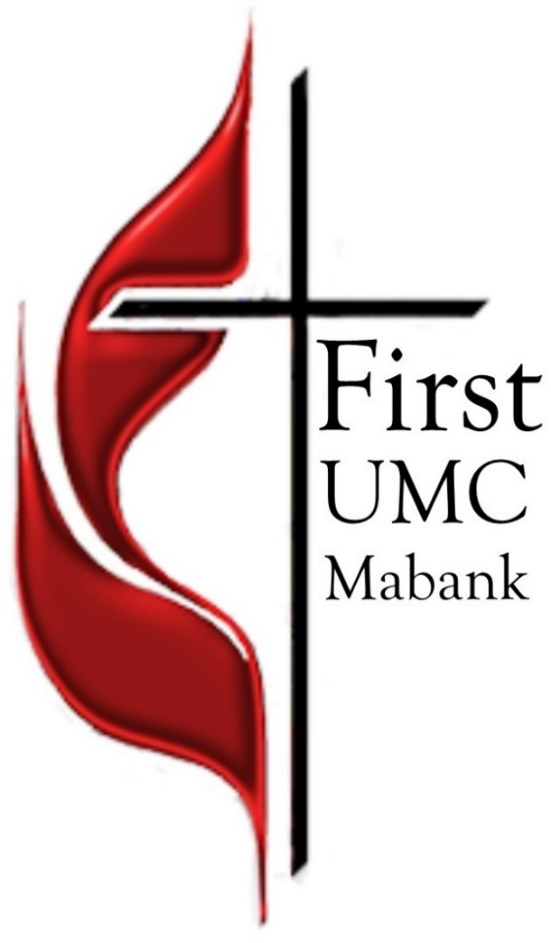

First United Methodist Church
501 South Third Street
Mabank, TX 75147

Phone: 903-887-3691 Fax: 903-887-0670
www.fumcmabank.com

