Palm Sunday with Communion
Sunday, April 5, 2020

Welcome! Thank you for joining us in service today. If you have any prayer concerns that you would like to be included in our weekly Caring Ministry email, please contact Mary Brown.
For assistance or questions, please contact the church office at 903-887-3691.

Altar Flowers: Today’s flowers are placed in honor of Doug and Jan Miller’s Wedding Anniversary.

Order of Worship:

Welcome & Announcements

Hymn “Hosanna, Loud Hosanna” UMH 278

Scripture Reading Philippians 2:5-11

Pastoral Prayer Rev. Dan Gurley

Hymn ”All Hail King Jesus”

Pastor’s Pals Rev. Gurley

Anthem ”Hosanna, Blessed Is He” Jubilation 5

Scripture Reading & Prayer Matthew 26:14, 27:66 Rev. Gurley

Message Rev. Gurley

Communion See packet provided

Closing “God Be With You” Rev. Gurley

Nurture Therefore encourage one another and build up one another, just as you also are doing. --1 Thessalonians 5:11

New Prayers: Continued Prayers:

Our Church  Ed Thompson  Walter Reaves  James Jones  Cathy Wallace  Jeffrey Van Horn  Becky George  Cody  Stacey Callaway  Peggy Broyles  Pool Family  Herman and Claudeen Salter | Diane Ackles,  James Adams,  Wyatt Alexander,  Alice Barker, Paula Beamis,  Joaquin Bejarano, Melissa Berger, Donna Bohannon, Chris Bonsal,  Greta Boultinghouse, Joe Boyd,  Jack Brandy, Rhonda Brooks,  Kelly Chancellor, Sue Cohn,  Sammy Coleman, Bill Cross,  Pat Davis, Judy Ellis, Terry Evans,  Chris Ensley, Rose Giordano  Matt Herron, Curtis Himes,  Trey Holthy, Cathy Hughes,  Susie Hull, Jean Hyde,  Kelli Janway, Madison Jordon,  Becky Keele, Levon Kristmer, Virginia Lane, Paulette Martin,  Rev. Ella McDonald,  John McMillian, Rhonda Morgan  Jean Morrow, Sherry Nash, Mitch Orr, John Otto, Mary Ann Richardson,  Clara Ries, Donnie Roberts,  Mary Smith, Scott Smith,  Patsy Speer, Jim Starrett,  Ethan Toler, Dee & Don Trull,  Deen Wier, and T.J. Wiersgalla. | Angels In The Wings:  Adda Beamgard  Gladys Caulking  Mary Friedel  Tommy Jobe  Jessie Kelley  Benita King  Linda Kuykendall  Mary Jo Lemons Pam Long  Knox Lowe Shirley Menasco  Betty Pollock  Charlotte Reppen  Cynthia Sperry Pat Underriner Peggy Whisenant

Financial Report: January - February 2020 Income: $91,454.39
Expense: ($112,559.69)

Don’t Forget….
You can give/tithe online through FUMCMabank.com.

Visit our Home Page
for additional information!

Church Staff:
Senior Pastor: Rev. Dan Gurley
dan@fumcmabank.com

Foundry House Ministries: Rev. Allison Partridge

Custodian: Kim Grimes

Director of Communications: Kelly Sasenbery
kelly@fumcmabank.com

Director of Music Ministries: Aaron Strum
aaron@fumcmabank.com

Financial Administrator: Rhonda Jones
rhonda@fumcmabank.com

Nursery Attendants: Yolanda & Carolyn Jimenez

Office Administrator & Pianist: Lance Douglas Gutierrez
lance@fumcmabank.com

Organist: Janice Sutton

Director of Children’s Ministries: Linda Jackson

Director of Youth Ministries: Olivia Pannell
olivia@fumcmabank.com

Normal Church Hours:
*Please remember all activities are canceled until further notice.
If you need assistance or have a question, please call the
church office at 903-887-3691.
Monday - Thursday: 9:00 a.m. – 3:00 p.m.
Friday & Saturday: Closed

(Normal Hours) Helping Hands Desk:
Tuesday – Thursday
9:00 - 11:00 a.m. – 1:00 - 3:00 p.m.

Sunday Schedule:
Online Worship at 10:00 a.m. via YouTube: FUMC Mabank.

Ⓒ2020 FUMC Mabank, All rights reserved. CCLI #183424

Would you like to know more about Jesus Christ, how to become a Christian or would like more information about church membership? Perhaps you just need
someone to pray with or talk to you. Please let us know!

Sunday, April 5, 2020
Palm Sunday
10:00 a.m. Online Worship Service
with Communion.
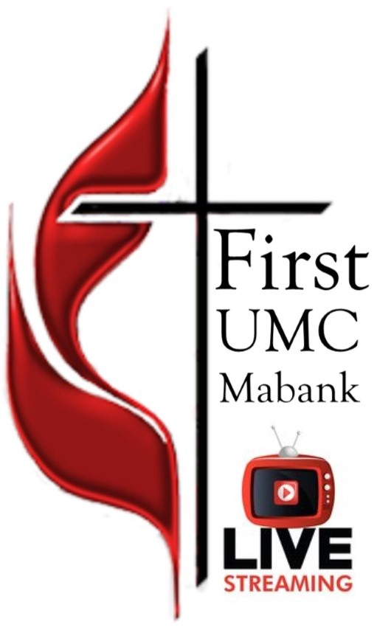

First United Methodist Church
501 South Third Street
Mabank, TX 75147

Phone: 903-887-3691 Fax: 903-887-0670
www.fumcmabank.com

